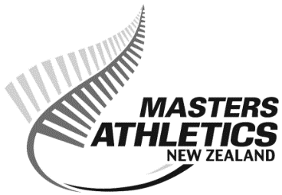
Service and Merit Awards – Nomination Form

In recognition for long-standing services to NZMA, two awards are available.

- Service Award representing 10 years of service to NZMA
- Merit Award representing 20 years service to NZMA

(Non NZMA members are eligible for Service Awards only.)

Nominations must be in writing with full details and submitted through an NZMA Centre.

(Name of Centre)
Name of Nominee | Year joined | Years of Service  (dates from…to ) | Positions held or Services rendered.

Other services performed or supporting information (show period covered)

Committee Comments and Recommendations

Signed by Centre President: ___________________________________

Closing date as advertised on website.
All forms can be submitted via e-mail to Andrew Stark (aws@xtra.co.nz)

